Option #1: Capstone Project: U.S. Organization
Juan Villarreal
MIS 581 - Capstone
Colorado State University – Global Campus
Dr. Osama Morad
October 2, 2020

NBA Home Court During COVID-19
Abstract
Data from the National Basketball Association (NBA) 2019-2020 season is examined to gain insights on the impact of COVID-19 on player and team performance. Due to the unique situation of isolation play for the remainder of the season, home court advantage will be analyzed to determine if any advantage exists in home play during isolation play. The hypothesis of this Capstone Project is player and team performance post COVID-19 will be similar statistically to away from home performance pre COVID-19. Initial results for player performance pre and post COVID home and away performance is varied for players but not for teams. There are players that performed better at home than away pre COVID but not post COVID. Team performance shows a higher point average at home than away pre COVID and the same is true post COVID. Analyzing the t-test output when comparing home and away pre and post COVID, the only significant comparison result is of team points post COVID and pre COVID away points average. The project code and documents can be accessed via this Github link.
Research Hypothesis
A hypothesis in research whether qualitative or quantitative states what the researcher is expecting to find (Research Hypotheses - Statistics Solutions, 2020). Therefore, understanding what a hypothesis is and why it is central to a research project aides in writing the correct hypothesis suitable for the dataset. The definition of a hypothesis is the logical educated guess about the nature of relationships between variables written in a testable statement (O’Leary, 2017).
The findings by Harris & Roebber (2019) found several attributes which impacted the performance of their predictive model for team win or loss outcomes. With these findings, then the research questions for this Capstone Project focus on the idea of COVID-19 pandemic isolation play of the NBA and performance of teams and players. The research question and related educated guess regarding home court advantage in the NBA is written as following. In a setting which has not previously been seen where teams play at a neutral site for an extended period of play, the educated guess is that team and player performance will resemble away from home court performance. The research question to be answered is if the play of NBA teams and players during COVID-19 in an isolated and neutral location resembles home or away performance pre COVID-19?
Null hypothesis is defined as the commonly accepted fact and is the opposite of the alternate hypothesis and in the context of research projects, researchers work to reject or disprove the null hypothesis (Null Hypothesis, 2020). As stated in the previous section, the hypothesis for this research project and equal to the null hypothesis is: Player and team performance post COVID-19 will be similar statistically to road match performance of players and teams pre COVID-19. This hypothesis is the null hypothesis for the research project because the goal will be to reject this claim. In this Capstone Project, the alternative hypothesis to the null hypothesis is the following: Player and team performance post COVID-19 will not be similar statistically to road match performance of players and team pre COVID-19.
Introduction
NBA Organization
The NBA is made up of 30 teams located across 21 states. The average valuation per team is $1.9 billion dollars and for the year 2018 all 30 teams combined for a generated $8 billion in revenue (Reiff, 2019). The NBA generates its revenue from the following services and business model. The NBA income comes from broadcast rights both nationally and internationally; advertising, merchandising, and concessions (Nath, 2018). For example, in 2016-2017 the NBA announced a 9-year TV deal with ESPN and Turner broadcasting for a total price of $24 billion dollars (Nath, 2018). On top of broadcasting rights, Basketball Related Income (BRI) is defined as income from ticket sales, concessions, local TV deals, merchandising rights, and apparel sales (Nath, 2018). Since the creation of the NBA, the league has grown its business within the USA and internationally. It is a medium for mass marketing of products, entertainment media for channels, and merchandise to sell. The NBA was chosen as the organization to focus the capstone project on in order to test a hypothesis regarding team and player performance away from a home court. The performance of a team on the court translates to higher TV deals, merchandise sales, sponsorships, and ticket sales. In this time of COVID-19 where NBA teams are centralized in a bubble in Orlando, Florida, there is no fans at games and therefore no home court advantage. The success in sport competitions meets the demand of fans but also in turn can lead to billions of dollars in subsequent marketing, finance, and management (Ribeiro et al., 2016). Ribeiro et al., (2016) concluded that at home a team performance is 0.13 points per minute more than at away matches.
In professional sports, various factors can lead to success and victory over an opponent. Such factors include coaching, team chemistry, physical ability, participant awareness, knowledge of the sport, experience, and the location of play. Specific factors providing an advantage to home teams and players can be seen for example in the National Hockey League (NHL) where home teams are given a favorable stick position in faceoffs; home crowd support to players providing added inspiration to perform better as evident in soccer World Cup play; travel distance on the visiting team; and lastly the factor of rest for the travel team as traveling is more taxing than being home (Carter, 2017) This Capstone Project focuses on the advantage of home court play as it relates to the NBA in the setting of COVID-19. COVID-19 health recommendations are to quarantine and isolate individuals as much as possible from possible infection. The NBA implemented a restart of the season by isolating all players, coaches, and essential team personnel from the general public by conducting team practices, games, training, and other team related activities in an isolation bubble. This scenario allows for the analysis of player and team performance away from home in an extended period.
NBA Data Set
The dataset will be game score and player statistical summaries gathered from NBA.com. The dataset provides team performance as wins and losses but also provides statistical metrics of team performance centered around shooting efficiency, rebounds, assists, total points, and turnovers. The difference will be in the analysis of the match outcomes pre and post COVID-19 quarantine play during the 2019-2020 NBA. The dataset was chosen because of its ease to compile data from an application programming interface (API) and because the data provided the variables of home, away, win, loss, points scored, and minutes played. The means of each player and team will be manually calculated to categorize the means into pre and post COVID home and away performance as seen in Appendix A Figure 3.
Objectives
The objective of this research project is to take advantage of a scenario in the NBA not previously seen. The scenario of having team and player performance data for half the season and later have the remainder of the season played out in an isolated environment with no true home court for the home team. The objective of this project is to explore the team and player performance pre-COVID19 and post-COVID19. This objective is specific to the game results of teams and players specifically point totals and minutes played. This proposal is achievable using three tools (Microsoft Excel, Python & Tableau). The results are relevant to NBA team managers and players in order to understand in a different angle if players can overcome the mental barriers of playing away from a home court to match output performance of home court play.
Overview of Study
Overview of Capstone Project is to support the notion that home court advantage exists. With an understanding of the attributes needed to overcome being away from home performance, this can lead to benefits of success on travel games. According to Bois (2011), home teams in the NBA during the past three seasons, if allowed to play at home would win 10.11% more games. Analyzing the team and player performance in the COVID-19 isolation bubble will provide the insights of player and team performance having a similarity to pre COVID performance. The research was done by taking NBA website data of players and teams via an API and formatting the data into categories of home/away, pre & post COVID, and calculating the points per minute average. The analysis on player and team performance can lead to decision making into finding the variables which contribute to favorable performance and ultimately help the organization win more games away from court and gain economic benefits from improved team performance.
Literature Review
The following literature is relevant to this research topic. The articles chosen for review of previous research on home field advantage provided insights into what variables have been investigated and questions answered. The article by Carter (2017) provided relevant historical aspects on home field advantage and findings such as the proven statistics in the NBA of field goals, free throws, rebounds, and turnovers are significant in the variability of winning at home. In other sports such as soccer, Carter (2017) notes in the World Cup soccer tournament the home team has a higher probability of advancing to later rounds of the tournament due to possibly crowd and psychological factors. The research conducted by Ribeiro et al., (2016), further adds to the topic of home field advantage by providing statistical proof from 14 years of data showing home teams win about 60% of the matches with the meaning there is a 10% higher chance to win than would be expected by chance. This finding by Ribeiro et al., (2016) provides guidance for this research project in terms of cementing the notion that home field advantage exists in the NBA due to various attributes. Lastly, the article by Harris & Roebber (2019) provides literature on not only research on home advantage factors in the NBA but also methodology to analyze the game and player data set.
The methodology used by Harris & Roebber (2019) was to acquire NBA team performance statistics for the past 32 seasons with player and team statistics and home advantage was defined as point differentials in quarter, game, and player stats. The same method will be used in this Capstone Project to compare the point differential of teams and players. By using artificial neural network (ANN) models, the outcome of the research by Harris & Roebber (2019) is conceptually different than this Capstone Project. For Harris & Roebber (2019), the goal of the project was to create a model to predict home win advantage by selecting the important variables from NBA statistics. This Capstone Project will focus on comparing available statistics of home and away matches pre and post COVID-19.
Research Design (Methodology, methods, limitations, ethical considerations)
The methodology for identifying, selecting, processing, and analyzing the NBA API data set followed a similar process as described in the literature review of Harris & Roebber (2019). The data was acquired only for the 2019-2020 season via the NBA API in Python. The data was formatted and organized into home and away groups with subsets of pre and post COVID in Microsoft Excel. Once the data was prepared, Tableau was used to plot the mean data of point per minute based on categories of home and away pre and post COVID.
The methods for acquiring the data and analysis of the data is as follows. The data was acquired by using the Python programming language and the libraries of NBA_api and Pandas. In the NBA_api, the static endpoints of teams and players was used in order to find the id’s for teams and players. In the endpoint of gamelogs, the id’s were used in order to get each corresponding set of data for teams and players. Data web scraping can be seen in Appendix A Figure 1 & 2 for player and teams respectively . Once the data was acquired then the variables of minutes, points, home or away matchup, and date were filtered for preliminary data exploration. Additional variables of pre and post COVID were added onto the data by means of filtering on the restart of league play date as seen in Appendix A Figure 3 via the tool of Microsoft Excel. A manual Excel calculation of points/minutes was done for both teams and players. This allowed for standardization of overtime play and take into consideration players that play more minutes as opposed to others. Once placed into an appropriate mean categories, the data was taken into Tableau for visualization of the win or loss disparities in players and teams point means.
The approach once the data was in Tableau was to plot home and away data sets and provided a color code to pre and post COVID play as seen in Appendix A Figure 6 and Figure 7.
Security concerns for this Capstone Project adhere to the web scraping laws of the USA and copyright guidelines. The methodology of the capstone project is to use web scraping to collect data from a website. Regulations for web scraping are the following. Web scraping is not illegal in the USA if the data acquired is does not require authentication and the data being acquired is not copyrighted or used for commercial purposes by copying and using the copyright data (Waterman, 2020). Access to the data from NBA.com is open to the public and does not require any special privileges or user access. The NBA is an entertainment company whose product is on television for the public to view and the statistics generated from games is also made public.
Privacy concerns of the data and potential harm from breach of the data is not considered in this project for two reasons. Reason one is the data is public and can be accessed by any person. Second, data matching and data mining via methods that requires consent from individuals that understand the consent to disclose information that can provide insights into their physical, mental, or behavioral health can be of security concern (Rajaretnam, 2014). In this capstone project, no data acquired will invade the privacy of a participant (player) and does not require secrecy or anonymity because there is no threat to the integrity of the person or reputation.
The research will follow the ethical considerations for data collection and research tools of: information gathered must not publicly identify participants if consent is to not be identified; no confidentiality agreement is required unless personal information or protection for participants is required; and follow ethical oversight. Ethical oversight is the establishment of humane approach to the treatment of research participants for the psychological, ethical, and sociological issues considered at the same level of importance as with participants in biomedical research (Borrett et al., 2017). For this capstone project, the data is acquired post game performance for athletes and as already stated the data is publicly available for analysis. No psychological, ethical, or humane concerns are present for the capstone project as is. If for example athletes in the NBA were asked to share what is their mental state or psychological state of mind before playing a game, then this personal private information would need to follow privacy guidelines and procedures just like as stated by Borrett et al., (2017) participants in a biomedical research project.
Limitations of the preliminary data and results are as follows. The dataset is skewed in terms of number of observations to pre COVID parameters for the obvious reason that there were more games played before COVID as compared to after. The number of players in the player data set is also small in nature because only top league players were chosen. This can possibly create too small a data set to find significance in the data results. Another limitation which can potentially hinder the results is the fact the post COVID data set is smaller than the pre COVID number of games played. The comparison of player and team performance might not be appropriate to compare due to this size of observations disparity.
Findings
The initial findings from the data set is in the data tables of Appendix A Figure 3, Figure 4, and Figure 5. Figure 3 shows the two tables, players and teams, overall home and away post & pre COVID points per minute. Figure 4 provides the result of categorizing the data into Home Adv or No Home Adv with the calculation of home point difference minus away. There is n = 55 total players analyzed in the data set. Without the COVID filter on the data, there is n = 33 players with a home advantage point differential and n = 22 where player scored higher away. Adding the pre COVID filter to the data set, there is n = 33 players with Home Adv and n = 22 without Home Adv attribute. Adding the Post COVID filter to the data set, there is n = 30 players with Home Adv and n = 25 no Home Adv post COVID.
For team performance, Figure 4 provides the results of home and away point differential pre & post COVID. Overall, for the entire season, there is n = 19 teams with Home Adv category value and n = 3 with no Home Adv value. Pre COVID, there is n =18 teams with Home Adv and n = 4 without Home Adv pre COVID. Post COVID, there is n = 12 teams with Home Adv and n = 10 teams with No Home Adv point differential attribute value.
The t-test results are seen in Figure 8, Figure 9, Figure 10, and Figure 11. T-test was used in order to compare the means of the hypothesized targets (pre COVID) and observation means (post COVID). The procedure of the t-test calculates the test statistic to compare the observed data to what is expected under the null hypothesis (pre COVID) (Understanding t-test., 2016). Figure 8 has a p-value of 0.200749 when comparing the means of player post COVID and pre COVID away performance. Figure 9 compares player post COVID and pre COVID home performance and has a p-value of 0.415026. Figure 10 compares team post COVID and pre COVID away performance and has a significant p-value of 0.008934. Figure 11 compares team post COVID and pre COVID home performance and has a p-value of 0.325821. With a significant value of 0.008934 indicates the post COVID team performance matches in a significant manner the pre COVID away performance. This means the null hypothesis is not rejected.
The NBA_api data set visualizations can be seen in Appendix A Figure 6 and Figure 7.From the visualizations, the team performance shows a similar difference in away and home play. Pre COVID, a 2.2 point difference is seen and Post COVID there is a difference of 1.7 point difference in favor of home play performance. In the player performance, Post COVID does not show the same results. Pre COVID for player home and away difference is 0.4 points average but Post COVID the difference is negligible of 0.001 point difference.
Conclusion
The research into the impact of isolation game play due to COVID-19 on home team and player performance provided valuable insights. For players, the various outcomes from the visualization of the data provides insights into player unknown factors which contribute to some players being away to perform well away from home court or in isolation play. The t-tests for player performance failed to reject the null hypothesis and did not offer significant results. For team performance, the average of all teams shows the same outcome of home and away performance variance pre COVID as well as post COVID. The null hypothesis is failed to be rejected as the t-test p-value of pre COVID away performance is similar statistically to post COVID team performance. This research write-up document has provided a foundation for further research into the impact of isolation play on player and team performance. Perhaps more research into variables impacting player performance can provide insights for the outcomes noted in this write-up.
Recommendations
For future research consideration and focus for this data set is to develop a standardized value for points. This can be done by calculating points per minute or quarters played. This calculated value will provide a standardization for players who do not play the same amount of time as other players. A significance test is also a recommendation in order to validate the results due to chance or the findings are not due to chance. Having a significance test such as a T-test or two variable hypothesis testing will provide the research validity. Also, consideration into opponents can be researched. The team outcome of this data set showed home and away point average split is higher for home values pre and post COVID but how do those values compare when looked at the opponent level? These findings on this initial research and follow up research will provide insights into the home court advantage in the NBA.

References
Bois, J. (2011, January 19). Home Advantage In Sports: A Scientific Study Of How Much It Affects Winning. Retrieved September 23, 2020, from SBNation.com website: https://www.sbnation.com/2011/1/19/1940438/home-field-advantage-sports-stats-data
Borrett, D. S., Sampson, H., & Cavoukian, A. (2017). Research ethics by design: A collaborative research design proposal. Research Ethics, 13(2), 84–91. https://doi.org/10.1177/1747016116673135
Carter, K. E. (2017). Relative Home-Court Advantage: The Impact of Travel on Team Production When One Team is Closer than its Opponent to a Neutral Game Site. Managerial & Decision Economics, 38(1), 76–91. https://doi.org/10.1002/mde.2742
‌Harris, A., & Roebber, P. (2019). NBA team home advantage: Identifying key factors using an artificial neural network. PloS One, 14(7), e0220630–. https://doi.org/10.1371/journal.pone.0220630
Null Hypothesis. (2020, July 9). Retrieved September 19, 2020, from Statistics How To website: https://www.statisticshowto.com/probability-and-statistics/null-hypothesis/
Rajaretnam, T. (2014). Data mining and data matching: regulatory and ethical considerations relating to privacy and confidentiality in medical data. Journal of International Commercial Law and Technology, 9(4), 294+. https://link-gale-com.csuglobal.idm.oclc.org/apps/doc/A395306163/AONE?u=colstglobal&sid=AONE&xid=cd1fc8d2
Reiff, N. (2019). How The NBA Makes Money: The Second-Largest Sport in the Country. (2020). Retrieved September 8, 2020, from Investopedia website: https://www.investopedia.com/articles/personal-finance/071415/how-nba-makes-money.asp#:~:text=Key%20Takeaways,about%20%248%20billion%20in%20revenue.
Research Hypotheses - Statistics Solutions. (2020). Retrieved September 19, 2020, from Statistics Solutions website: https://www.statisticssolutions.com/research-hypotheses/
Ribeiro, H. V., Mukherjee, S., & Zeng, X. H. (2016). The Advantage of Playing Home in NBA: Microscopic, Team-Specific and Evolving Features. PloS one, 11(3), e0152440. https://doi.org/10.1371/journal.pone.0152440
O’Leary, Z. (2017). The essential guide to doing your research project (3rd ed.). Thousand Oaks, CA: Sage Publishing. ISBN: 9781473952089
Understanding t-test. (2016). Understanding t-Tests: t-values and t-distributions. Retrieved October 5, 2020, from Minitab.com website: https://blog.minitab.com/blog/adventures-in-statistics-2/understanding-t-tests-t-values-and-t-distributions
Waterman, T. (2020, January 29). Web scraping is now legal - Tom Waterman - Medium. Retrieved September 22, 2020, from Medium website: https://medium.com/@tjwaterman99/web-scraping-is-now-legal-6bf0e5730a78

Appendix A
Figure 1 – Players Data Scraping
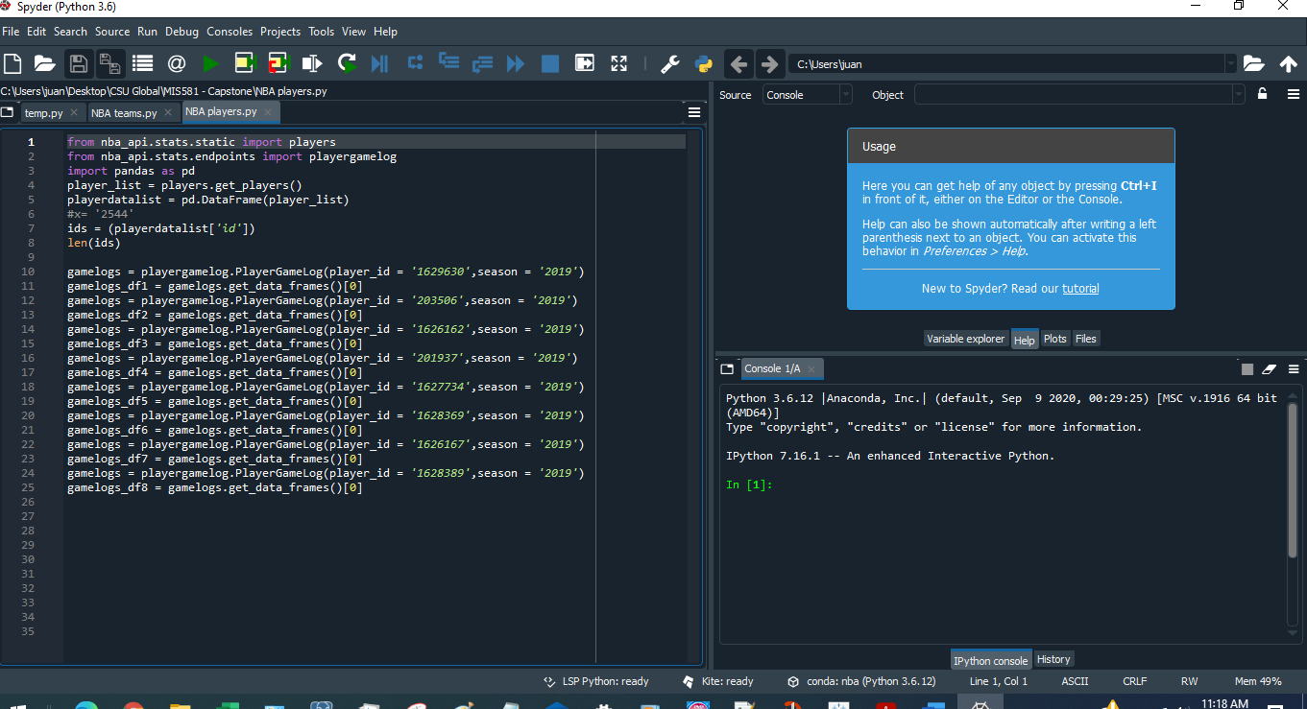
Figure 2 – Team Data Scraping
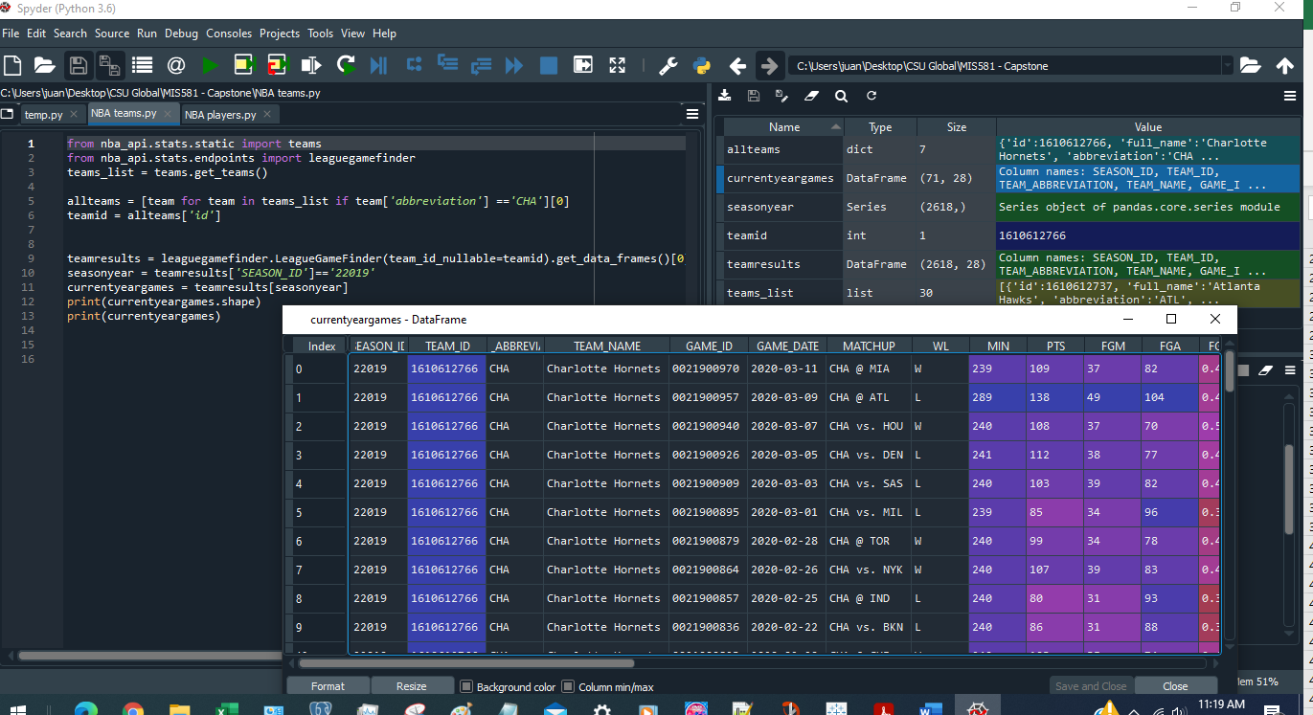

Figure 3 – Data Exploration
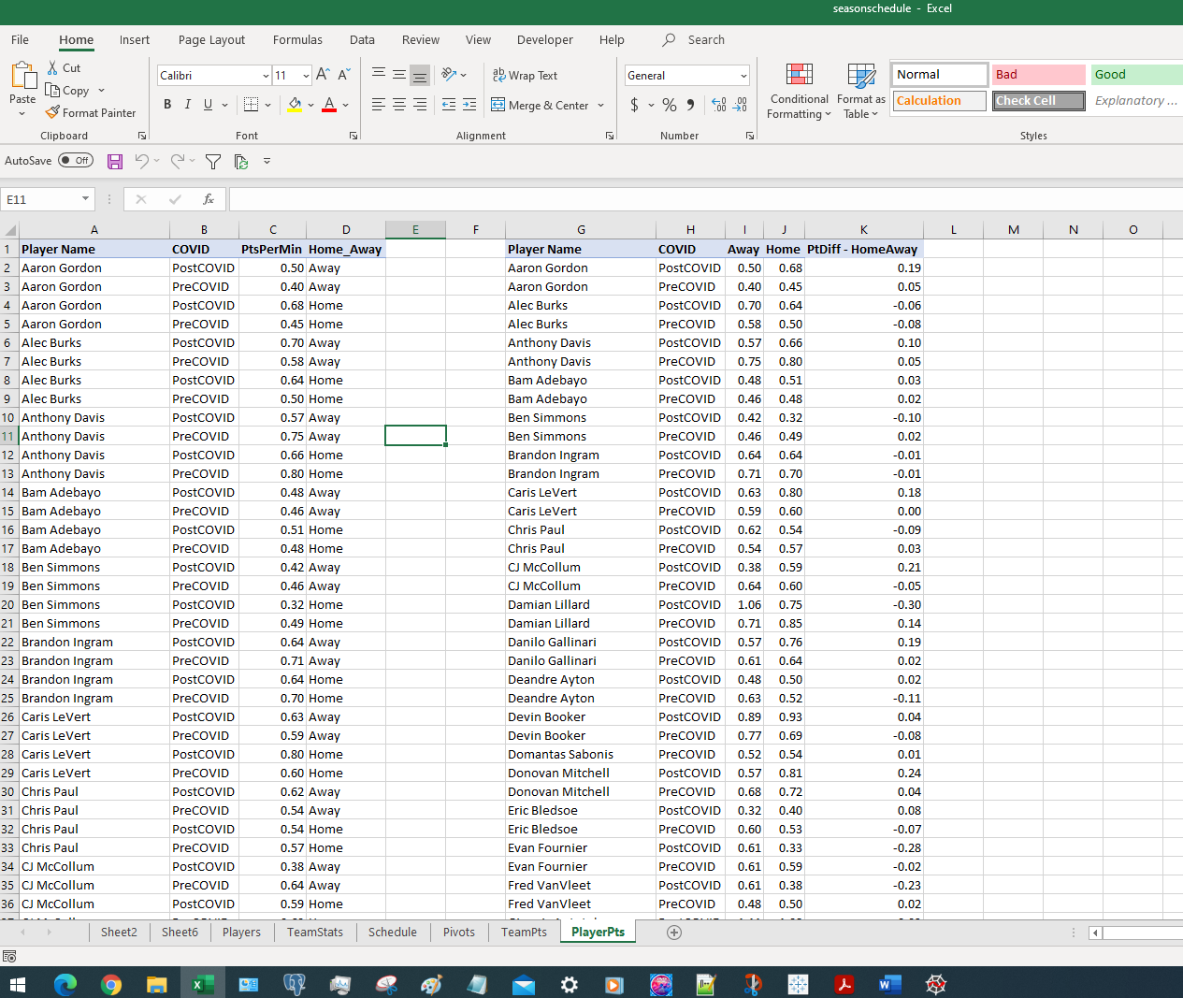
Figure 4 – Player Point Per Minute Difference
 |  | Pts Per Minute
Player Name | COVID | Away | Home | Difference | Home Advantage | Grand Total
Aaron Gordon |  | 0.41 | 0.47 | 0.06 | Home Adv | 0.44
 | PostCOVID | 0.50 | 0.68 | 0.19 | Home Adv | 0.59
 | PreCOVID | 0.40 | 0.45 | 0.05 | Home Adv | 0.43
Alec Burks |  | 0.60 | 0.51 | -0.08 | No Home Adv | 0.56
 | PostCOVID | 0.70 | 0.64 | -0.06 | No Home Adv | 0.67
 | PreCOVID | 0.58 | 0.50 | -0.08 | No Home Adv | 0.54
Anthony Davis |  | 0.72 | 0.78 | 0.06 | Home Adv | 0.75
 | PostCOVID | 0.57 | 0.66 | 0.10 | Home Adv | 0.61
 | PreCOVID | 0.75 | 0.80 | 0.05 | Home Adv | 0.77
Ben Simmons |  | 0.46 | 0.48 | 0.02 | Home Adv | 0.47
 | PostCOVID | 0.42 | 0.32 | -0.10 | No Home Adv | 0.39
 | PreCOVID | 0.46 | 0.49 | 0.02 | Home Adv | 0.47
Brandon Ingram |  | 0.71 | 0.69 | -0.02 | No Home Adv | 0.70
 | PostCOVID | 0.64 | 0.64 | -0.01 | No Home Adv | 0.64
 | PreCOVID | 0.71 | 0.70 | -0.01 | No Home Adv | 0.70
Caris LeVert |  | 0.60 | 0.63 | 0.03 | Home Adv | 0.62
 | PostCOVID | 0.63 | 0.80 | 0.18 | Home Adv | 0.74
 | PreCOVID | 0.59 | 0.60 | 0.00 | Home Adv | 0.60
Chris Paul |  | 0.55 | 0.56 | 0.02 | Home Adv | 0.56
 | PostCOVID | 0.62 | 0.54 | -0.09 | No Home Adv | 0.57
 | PreCOVID | 0.54 | 0.57 | 0.03 | Home Adv | 0.55
CJ McCollum |  | 0.61 | 0.60 | -0.02 | No Home Adv | 0.61
 | PostCOVID | 0.38 | 0.59 | 0.21 | Home Adv | 0.49
 | PreCOVID | 0.64 | 0.60 | -0.05 | No Home Adv | 0.62
Damian Lillard |  | 0.75 | 0.84 | 0.09 | Home Adv | 0.79
 | PostCOVID | 1.06 | 0.75 | -0.30 | No Home Adv | 0.90
 | PreCOVID | 0.71 | 0.85 | 0.14 | Home Adv | 0.78
Danilo Gallinari |  | 0.61 | 0.65 | 0.04 | Home Adv | 0.63
 | PostCOVID | 0.57 | 0.76 | 0.19 | Home Adv | 0.68
 | PreCOVID | 0.61 | 0.64 | 0.02 | Home Adv | 0.63
Deandre Ayton |  | 0.60 | 0.52 | -0.08 | No Home Adv | 0.56
 | PostCOVID | 0.48 | 0.50 | 0.02 | Home Adv | 0.49
 | PreCOVID | 0.63 | 0.52 | -0.11 | No Home Adv | 0.58
Devin Booker |  | 0.78 | 0.71 | -0.07 | No Home Adv | 0.75
 | PostCOVID | 0.89 | 0.93 | 0.04 | Home Adv | 0.91
 | PreCOVID | 0.77 | 0.69 | -0.08 | No Home Adv | 0.72
Domantas Sabonis |  | 0.52 | 0.54 | 0.01 | Home Adv | 0.53
 | PreCOVID | 0.52 | 0.54 | 0.01 | Home Adv | 0.53
Donovan Mitchell |  | 0.67 | 0.73 | 0.06 | Home Adv | 0.70
 | PostCOVID | 0.57 | 0.81 | 0.24 | Home Adv | 0.69
 | PreCOVID | 0.68 | 0.72 | 0.04 | Home Adv | 0.70
Eric Bledsoe |  | 0.58 | 0.52 | -0.06 | No Home Adv | 0.55
 | PostCOVID | 0.32 | 0.40 | 0.08 | Home Adv | 0.37
 | PreCOVID | 0.60 | 0.53 | -0.07 | No Home Adv | 0.57
Evan Fournier |  | 0.61 | 0.57 | -0.03 | No Home Adv | 0.59
 | PostCOVID | 0.61 | 0.33 | -0.28 | No Home Adv | 0.50
 | PreCOVID | 0.61 | 0.59 | -0.02 | No Home Adv | 0.60
Fred VanVleet |  | 0.50 | 0.49 | -0.01 | No Home Adv | 0.49
 | PostCOVID | 0.61 | 0.38 | -0.23 | No Home Adv | 0.50
 | PreCOVID | 0.48 | 0.50 | 0.02 | Home Adv | 0.49
Giannis Antetokounmpo |  | 0.93 | 1.04 | 0.11 | Home Adv | 0.98
 | PostCOVID | 1.11 | 1.08 | -0.03 | No Home Adv | 1.09
 | PreCOVID | 0.92 | 1.04 | 0.12 | Home Adv | 0.97
Goran Dragic |  | 0.53 | 0.61 | 0.08 | Home Adv | 0.57
 | PostCOVID | 0.63 | 0.66 | 0.02 | Home Adv | 0.65
 | PreCOVID | 0.52 | 0.61 | 0.09 | Home Adv | 0.56
Ja Morant |  | 0.53 | 0.61 | 0.08 | Home Adv | 0.57
 | PostCOVID | 0.44 | 0.56 | 0.12 | Home Adv | 0.50
 | PreCOVID | 0.54 | 0.62 | 0.08 | Home Adv | 0.58
Jamal Murray |  | 0.59 | 0.54 | -0.05 | No Home Adv | 0.57
 | PostCOVID | 0.83 | 0.49 | -0.34 | No Home Adv | 0.66
 | PreCOVID | 0.57 | 0.55 | -0.03 | No Home Adv | 0.56
James Harden |  | 0.93 | 0.95 | 0.02 | Home Adv | 0.94
 | PostCOVID | 0.94 | 1.03 | 0.09 | Home Adv | 0.99
 | PreCOVID | 0.93 | 0.94 | 0.01 | Home Adv | 0.94
Jaren Jackson Jr. |  | 0.61 | 0.59 | -0.02 | No Home Adv | 0.60
 | PostCOVID | 0.73 | 0.60 | -0.13 | No Home Adv | 0.68
 | PreCOVID | 0.60 | 0.59 | -0.02 | No Home Adv | 0.59
Jaylen Brown |  | 0.56 | 0.65 | 0.09 | Home Adv | 0.60
 | PostCOVID | 0.50 | 0.72 | 0.23 | Home Adv | 0.59
 | PreCOVID | 0.57 | 0.64 | 0.07 | Home Adv | 0.61
Jayson Tatum |  | 0.66 | 0.72 | 0.05 | Home Adv | 0.69
 | PostCOVID | 0.62 | 0.87 | 0.24 | Home Adv | 0.73
 | PreCOVID | 0.67 | 0.70 | 0.03 | Home Adv | 0.68
Joel Embiid |  | 0.70 | 0.80 | 0.10 | Home Adv | 0.75
 | PostCOVID | 0.76 | 0.62 | -0.14 | No Home Adv | 0.70
 | PreCOVID | 0.69 | 0.82 | 0.13 | Home Adv | 0.76
Josh Jackson |  | 0.56 | 0.37 | -0.19 | No Home Adv | 0.49
 | PostCOVID | 0.62 | 0.22 | -0.39 | No Home Adv | 0.32
 | PreCOVID | 0.56 | 0.45 | -0.11 | No Home Adv | 0.52
Jrue Holiday |  | 0.55 | 0.55 | 0.01 | Home Adv | 0.55
 | PostCOVID | 0.38 | 0.49 | 0.12 | Home Adv | 0.45
 | PreCOVID | 0.56 | 0.56 | 0.00 | Home Adv | 0.56
Kawhi Leonard |  | 0.85 | 0.84 | -0.01 | No Home Adv | 0.84
 | PostCOVID | 0.80 | 0.89 | 0.09 | Home Adv | 0.85
 | PreCOVID | 0.85 | 0.83 | -0.02 | No Home Adv | 0.84
Kelly Oubre Jr. |  | 0.49 | 0.58 | 0.09 | Home Adv | 0.54
 | PreCOVID | 0.49 | 0.58 | 0.09 | Home Adv | 0.54
Kemba Walker |  | 0.67 | 0.62 | -0.05 | No Home Adv | 0.64
 | PostCOVID | 0.70 | 0.38 | -0.32 | No Home Adv | 0.60
 | PreCOVID | 0.67 | 0.64 | -0.03 | No Home Adv | 0.65
Khris Middleton |  | 0.70 | 0.71 | 0.01 | Home Adv | 0.70
 | PostCOVID | 0.68 | 0.67 | -0.01 | No Home Adv | 0.68
 | PreCOVID | 0.70 | 0.71 | 0.01 | Home Adv | 0.71
Kristaps Porzingis |  | 0.62 | 0.64 | 0.02 | Home Adv | 0.63
 | PostCOVID | 0.81 | 0.86 | 0.05 | Home Adv | 0.84
 | PreCOVID | 0.61 | 0.61 | 0.00 | Home Adv | 0.61
Kyle Kuzma |  | 0.51 | 0.49 | -0.02 | No Home Adv | 0.50
 | PostCOVID | 0.52 | 0.54 | 0.02 | Home Adv | 0.53
 | PreCOVID | 0.51 | 0.48 | -0.03 | No Home Adv | 0.50
Kyle Lowry |  | 0.55 | 0.51 | -0.04 | No Home Adv | 0.53
 | PostCOVID | 0.46 | 0.58 | 0.12 | Home Adv | 0.52
 | PreCOVID | 0.57 | 0.51 | -0.06 | No Home Adv | 0.54
LaMarcus Aldridge |  | 0.55 | 0.59 | 0.04 | Home Adv | 0.57
 | PreCOVID | 0.55 | 0.59 | 0.04 | Home Adv | 0.57
LeBron James |  | 0.72 | 0.76 | 0.05 | Home Adv | 0.74
 | PostCOVID | 0.70 | 0.75 | 0.05 | Home Adv | 0.73
 | PreCOVID | 0.72 | 0.76 | 0.04 | Home Adv | 0.74
Lou Williams |  | 0.59 | 0.67 | 0.08 | Home Adv | 0.63
 | PostCOVID | 0.63 | 0.56 | -0.07 | No Home Adv | 0.60
 | PreCOVID | 0.59 | 0.68 | 0.09 | Home Adv | 0.64
Luka Doncic |  | 0.88 | 0.87 | -0.01 | No Home Adv | 0.87
 | PostCOVID | 1.07 | 0.77 | -0.30 | No Home Adv | 0.90
 | PreCOVID | 0.85 | 0.88 | 0.03 | Home Adv | 0.87
Malcolm Brogdon |  | 0.54 | 0.50 | -0.04 | No Home Adv | 0.52
 | PostCOVID | 0.57 | 0.54 | -0.03 | No Home Adv | 0.56
 | PreCOVID | 0.53 | 0.50 | -0.04 | No Home Adv | 0.51
Marc Gasol |  | 0.23 | 0.35 | 0.11 | Home Adv | 0.29
 | PostCOVID | 0.34 | 0.29 | -0.05 | No Home Adv | 0.32
 | PreCOVID | 0.21 | 0.36 | 0.15 | Home Adv | 0.28
Markelle Fultz |  | 0.46 | 0.42 | -0.03 | No Home Adv | 0.44
 | PostCOVID | 0.48 | 0.59 | 0.11 | Home Adv | 0.54
 | PreCOVID | 0.45 | 0.40 | -0.05 | No Home Adv | 0.43
Mike Conley |  | 0.46 | 0.51 | 0.04 | Home Adv | 0.49
 | PostCOVID | 0.48 | 0.65 | 0.17 | Home Adv | 0.56
 | PreCOVID | 0.46 | 0.49 | 0.03 | Home Adv | 0.48
Myles Turner |  | 0.39 | 0.43 | 0.04 | Home Adv | 0.41
 | PostCOVID | 0.51 | 0.44 | -0.07 | No Home Adv | 0.48
 | PreCOVID | 0.37 | 0.43 | 0.06 | Home Adv | 0.40
Nikola Jokic |  | 0.62 | 0.60 | -0.02 | No Home Adv | 0.61
 | PostCOVID | 0.55 | 0.55 | 0.00 | Home Adv | 0.55
 | PreCOVID | 0.63 | 0.61 | -0.02 | No Home Adv | 0.62
Nikola Vucevic |  | 0.56 | 0.65 | 0.09 | Home Adv | 0.61
 | PostCOVID | 0.71 | 0.69 | -0.01 | No Home Adv | 0.70
 | PreCOVID | 0.54 | 0.65 | 0.10 | Home Adv | 0.59
OG Anunoby |  | 0.34 | 0.34 | 0.00 | Home Adv | 0.34
 | PostCOVID | 0.29 | 0.36 | 0.07 | Home Adv | 0.32
 | PreCOVID | 0.35 | 0.34 | -0.01 | No Home Adv | 0.34
Paul George |  | 0.67 | 0.82 | 0.15 | Home Adv | 0.74
 | PostCOVID | 0.76 | 0.86 | 0.10 | Home Adv | 0.79
 | PreCOVID | 0.65 | 0.81 | 0.16 | Home Adv | 0.73
Ricky Rubio |  | 0.39 | 0.43 | 0.04 | Home Adv | 0.41
 | PostCOVID | 0.49 | 0.45 | -0.05 | No Home Adv | 0.47
 | PreCOVID | 0.37 | 0.43 | 0.06 | Home Adv | 0.41
Rudy Gobert |  | 0.45 | 0.43 | -0.03 | No Home Adv | 0.44
 | PostCOVID | 0.43 | 0.53 | 0.10 | Home Adv | 0.48
 | PreCOVID | 0.46 | 0.42 | -0.04 | No Home Adv | 0.44
Seth Curry |  | 0.52 | 0.43 | -0.09 | No Home Adv | 0.48
 | PostCOVID | 0.54 | 0.11 | -0.43 | No Home Adv | 0.37
 | PreCOVID | 0.52 | 0.46 | -0.07 | No Home Adv | 0.49
Steven Adams |  | 0.35 | 0.44 | 0.09 | Home Adv | 0.39
 | PostCOVID | 0.32 | 0.41 | 0.09 | Home Adv | 0.38
 | PreCOVID | 0.35 | 0.44 | 0.09 | Home Adv | 0.39
Tobias Harris |  | 0.55 | 0.59 | 0.04 | Home Adv | 0.57
 | PostCOVID | 0.63 | 0.75 | 0.12 | Home Adv | 0.68
 | PreCOVID | 0.54 | 0.58 | 0.04 | Home Adv | 0.56
Victor Oladipo |  | 0.52 | 0.51 | -0.01 | No Home Adv | 0.52
 | PostCOVID | 0.48 | 0.53 | 0.04 | Home Adv | 0.50
 | PreCOVID | 0.54 | 0.51 | -0.03 | No Home Adv | 0.52
Bam Adebayo |  | 0.46 | 0.48 | 0.02 | Home Adv | 0.47
 | PostCOVID | 0.48 | 0.51 | 0.03 | Home Adv | 0.49
 | PreCOVID | 0.46 | 0.48 | 0.02 | Home Adv | 0.47
Grand Total |  | 0.58 | 0.61 | 0.02 | Home Adv | 0.60

Figure 5 – Team Point Difference Per Minute
 |  | Pts Per Minute
TEAM_NAME | COVID | Away | Home | Difference | Home Advantage | Grand Total
Boston Celtics |  | 0.46 | 0.48 | 0.02 | Home Adv | 0.47
 | PostCOVID | 0.48 | 0.50 | 0.01 | Home Adv | 0.49
 | PreCOVID | 0.46 | 0.48 | 0.02 | Home Adv | 0.47
Brooklyn Nets |  | 0.46 | 0.47 | 0.01 | Home Adv | 0.46
 | PostCOVID | 0.49 | 0.51 | 0.02 | Home Adv | 0.50
 | PreCOVID | 0.45 | 0.46 | 0.01 | Home Adv | 0.46
Dallas Mavericks |  | 0.48 | 0.48 | 0.00 | No Home Adv | 0.48
 | PostCOVID | 0.46 | 0.52 | 0.06 | Home Adv | 0.49
 | PreCOVID | 0.49 | 0.48 | -0.01 | No Home Adv | 0.48
Denver Nuggets |  | 0.45 | 0.46 | 0.01 | Home Adv | 0.46
 | PostCOVID | 0.49 | 0.46 | -0.03 | No Home Adv | 0.48
 | PreCOVID | 0.45 | 0.46 | 0.01 | Home Adv | 0.46
Houston Rockets |  | 0.49 | 0.49 | 0.01 | Home Adv | 0.49
 | PostCOVID | 0.49 | 0.45 | -0.04 | No Home Adv | 0.47
 | PreCOVID | 0.48 | 0.50 | 0.01 | Home Adv | 0.49
Indiana Pacers |  | 0.45 | 0.46 | 0.01 | Home Adv | 0.45
 | PostCOVID | 0.43 | 0.49 | 0.06 | Home Adv | 0.46
 | PreCOVID | 0.45 | 0.45 | 0.00 | Home Adv | 0.45
Los Angeles Clippers |  | 0.48 | 0.49 | 0.01 | Home Adv | 0.48
 | PostCOVID | 0.49 | 0.48 | -0.02 | No Home Adv | 0.48
 | PreCOVID | 0.48 | 0.49 | 0.01 | Home Adv | 0.48
Los Angeles Lakers |  | 0.47 | 0.48 | 0.01 | Home Adv | 0.47
 | PostCOVID | 0.43 | 0.45 | 0.02 | Home Adv | 0.44
 | PreCOVID | 0.47 | 0.48 | 0.01 | Home Adv | 0.48
Memphis Grizzlies |  | 0.46 | 0.47 | 0.01 | Home Adv | 0.47
 | PostCOVID | 0.45 | 0.47 | 0.02 | Home Adv | 0.46
 | PreCOVID | 0.47 | 0.47 | 0.01 | Home Adv | 0.47
Miami Heat |  | 0.45 | 0.48 | 0.03 | Home Adv | 0.46
 | PostCOVID | 0.47 | 0.46 | -0.01 | No Home Adv | 0.46
 | PreCOVID | 0.44 | 0.48 | 0.03 | Home Adv | 0.46
Milwaukee Bucks |  | 0.48 | 0.50 | 0.02 | Home Adv | 0.49
 | PostCOVID | 0.49 | 0.49 | 0.00 | Home Adv | 0.49
 | PreCOVID | 0.48 | 0.51 | 0.03 | Home Adv | 0.49
New Orleans Pelicans |  | 0.47 | 0.49 | 0.01 | Home Adv | 0.48
 | PostCOVID | 0.48 | 0.46 | -0.02 | No Home Adv | 0.47
 | PreCOVID | 0.47 | 0.49 | 0.02 | Home Adv | 0.48
Oklahoma City Thunder |  | 0.44 | 0.47 | 0.02 | Home Adv | 0.46
 | PostCOVID | 0.41 | 0.47 | 0.06 | Home Adv | 0.44
 | PreCOVID | 0.45 | 0.47 | 0.02 | Home Adv | 0.46
Orlando Magic |  | 0.45 | 0.44 | -0.01 | No Home Adv | 0.45
 | PostCOVID | 0.46 | 0.48 | 0.02 | Home Adv | 0.47
 | PreCOVID | 0.45 | 0.44 | -0.01 | No Home Adv | 0.44
Philadelphia 76ers |  | 0.45 | 0.47 | 0.02 | Home Adv | 0.46
 | PostCOVID | 0.50 | 0.50 | -0.01 | No Home Adv | 0.50
 | PreCOVID | 0.44 | 0.47 | 0.03 | Home Adv | 0.45
Phoenix Suns |  | 0.47 | 0.48 | 0.01 | Home Adv | 0.47
 | PostCOVID | 0.51 | 0.51 | 0.00 | No Home Adv | 0.51
 | PreCOVID | 0.46 | 0.47 | 0.01 | Home Adv | 0.47
Portland Trail Blazers |  | 0.47 | 0.48 | 0.02 | Home Adv | 0.48
 | PostCOVID | 0.54 | 0.50 | -0.04 | No Home Adv | 0.52
 | PreCOVID | 0.46 | 0.48 | 0.02 | Home Adv | 0.47
Sacramento Kings |  | 0.45 | 0.46 | 0.00 | Home Adv | 0.45
 | PostCOVID | 0.50 | 0.48 | -0.02 | No Home Adv | 0.49
 | PreCOVID | 0.45 | 0.45 | 0.00 | Home Adv | 0.45
San Antonio Spurs |  | 0.47 | 0.47 | 0.00 | Home Adv | 0.47
 | PostCOVID | 0.49 | 0.52 | 0.03 | Home Adv | 0.50
 | PreCOVID | 0.47 | 0.47 | 0.00 | No Home Adv | 0.47
Toronto Raptors |  | 0.46 | 0.48 | 0.02 | Home Adv | 0.47
 | PostCOVID | 0.47 | 0.45 | -0.02 | No Home Adv | 0.46
 | PreCOVID | 0.46 | 0.48 | 0.02 | Home Adv | 0.47
Utah Jazz |  | 0.46 | 0.46 | 0.01 | Home Adv | 0.46
 | PostCOVID | 0.44 | 0.48 | 0.05 | Home Adv | 0.46
 | PreCOVID | 0.46 | 0.46 | 0.00 | Home Adv | 0.46
Washington Wizards |  | 0.48 | 0.47 | 0.00 | No Home Adv | 0.47
 | PostCOVID | 0.43 | 0.44 | 0.01 | Home Adv | 0.44
 | PreCOVID | 0.48 | 0.48 | -0.01 | No Home Adv | 0.48
Grand Total |  | 0.46 | 0.47 | 0.01 | Home Adv | 0.47

Figure 6 – Plot Player Point Avg
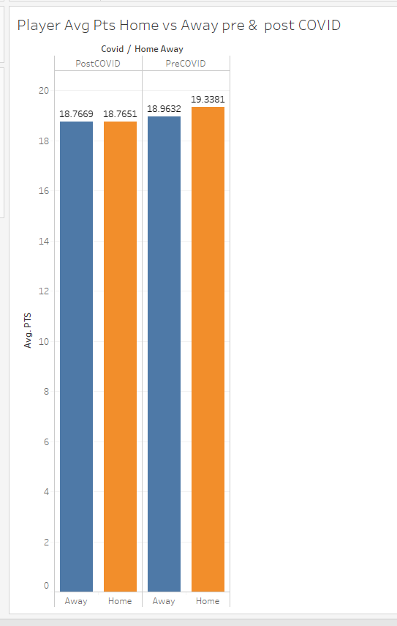

Figure 7 – Team Pts Avg
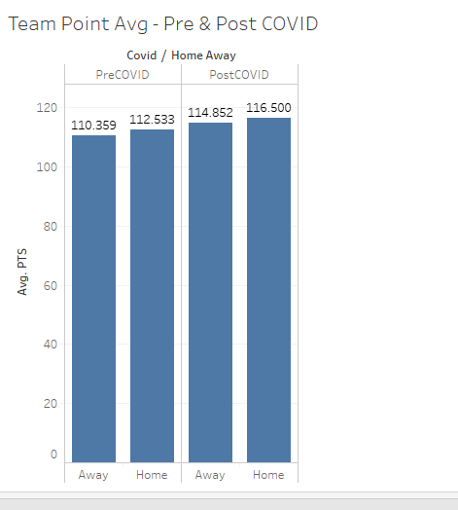

Figure 8 – Player Post COVID and Pre COVID Away Performance
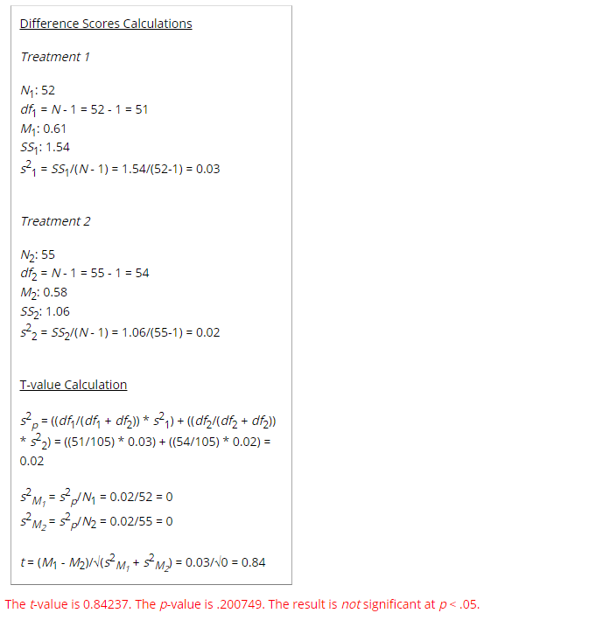

Figure 9 - Player Post COVID and Pre COVID Home Performance
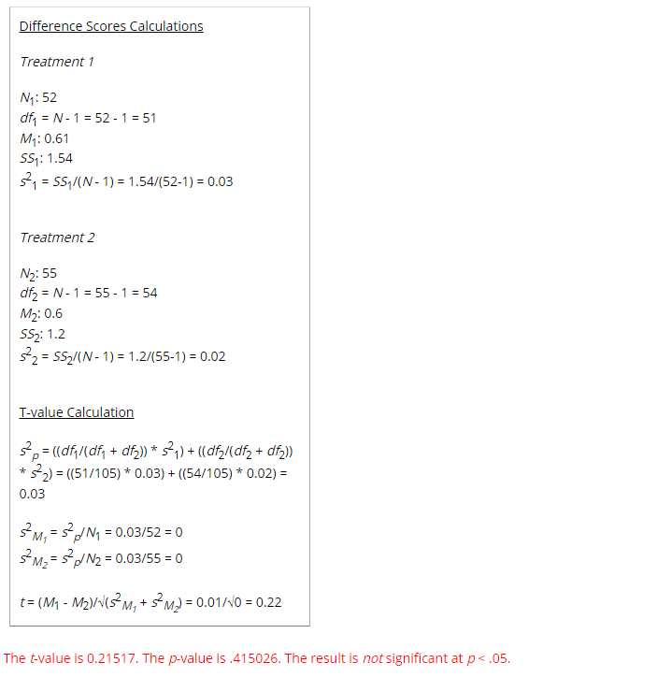

Figure 10 – Team Post COVID and Pre COVID Away Performance
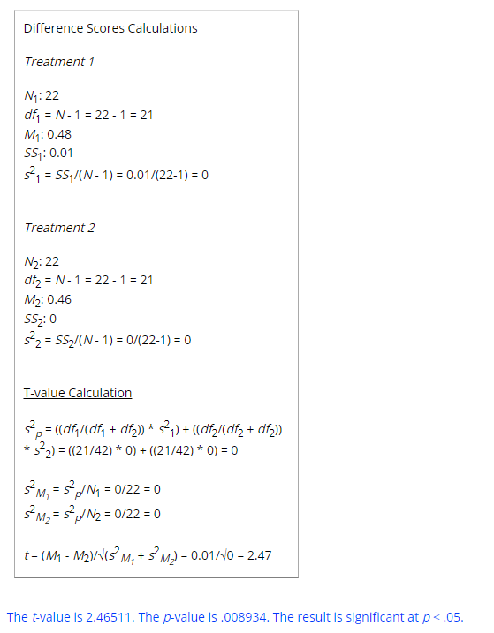

Figure 11 - Team Post COVID and Pre COVID Home Performance
